Effective medium approximations (EMA) utilize a mathematical model to approximate the holistic properties of composite materials by averaging the values of the constituent parts’ properties. Certain assumptions regarding the constituent materials will be made, e.g. that gases behave ideally or all collisions are perfectly elastic. Though EMA cannot generate an exact result, its approximations are useful in creating a set of parameters and thereby aids in predicting experimental results.

In this case, a derivation of the Bruggeman effective medium equation was utilized to model the magnetic permeability of a hydrogel colloid with magnetic nanoparticles dispersed within the hydrogel solvent. Whereas the original Bruggeman equation was in the form: i i(i - e)/[i + (*n* - 1)e ] = 0 and modeled electric permittivity in terms of effective conductivity and the dielectric constant, I rearranged it to solve for e / 0 (see Appendix 1 for details). Additionally, the derived equations’ units had electric permittivity replaced by magnetic permeability, effective conductivity by the nanoparticles’ volume fraction, and the dielectric constant by effective permeability.

For the homogeneously-dispersed model, the Bruggeman equation was rewritten for $μ$ as a function of $η$. $μ$ represented the effective permeability of the colloid as a whole, while $η$ stood for the volume fraction of the magnetic nanoparticles in solution. The equation was then written in terms of $β$, where $β$ was a simplification of an expression in terms of $η$. The function was then further modified to solve for/0 where0 represented the magnetic permeability of the hydrogel solvent. The equation thus yielded a result of the effective colloid permeability as a fraction of the permeability of the hydrogel. Also, $β$ was replaced by $γ$, so the final equation gave /0 in terms of . A constant ,n /0, represented the predefined permeability of the nanoparticles as a fraction of the hydrogel’s permeability and was fixed at various values [assigned to me by Professor Siegel].

For the bead-concentrated model, the above equation was largely kept identical, the only differences being that $η$ was replaced by b to reflect that the volume fraction of the nanoparticles was in the beads, rather than the hydrogel solvent. The result, b /0, the magnetic permeability of beads as a fraction of the entire colloid’s permeability, was then inserted into the second equation as a replacement for the constant n /0, the nanoparticles’ predefined permeability and the variable replaced by $Φ$, the volume fraction of the beads in the hydrogel solvent. Thus, the second equation gave the effective permeability of the nanoparticles as a fraction of the hydrogel, as a function of the beads’ volume fraction in said hydrogel, given the prior-solved permeability of the nanoparticles per bead.

As per Professor Siegel’s stipulations, $η$ and b were evaluated from 0 to 0.3, inclusive, on intervals of 0.01; $Φ$ from 0 to 0.3, inclusive, on intervals of 0.01; and n /0 was set at 10, 20, 40, and 80. The homogeneously-dispersed model’s data is displayed on the first graph, which shows / 0 as a function of $η$. The four curves each correspond with a different value of the constant n / 0, as shown by the legend on the right. Due to the nature of the bead-concentrated model, its data is displayed with / 0 as a function of $Φ$, but with the “constant” b / 0 evaluated for every value of $Φ$ (which is shown by the ascending “columns” of data for each $Φ$). The major difference in the two graphs is, therefore, that the homogeneously-dispersed model has its ultimate permeability evaluated for four discrete constants (of the nanoparticles’ permeability in solvent), while the bead-concentrated model’s permeability is evaluated on a sliding scale between the minimum and maximum permeabilities of the nanoparticles in the beads, rather than the entire colloid. However, for the sake of graphical commutability between the models, four values of b / 0 were selected and the graphs plotted in the same manner as the homogeneously-dispersed model.

For the homogeneously-dispersed model, the final values (of effective permeability as a fraction of solvent permeability) began, with the volume fraction of the nanoparticles at 0.01, at 1 for each value of the constant n / 0; and topped out, with the volume fraction at 0.30, at 2.261, 2.945, 3.806, and 4.831 for the constant values of 10, 20, 40, and 80, respectively. Thus, depending on the predetermined permeability of the individual nanoparticles, the total colloid permeability ranged from two to four times that of the hydrogel solvent. Naturally, for intermediate volume fractions between 0.01 and 0.3, the colloid permeability exhibited a smooth proportional increase as the volume fraction rose.

The bead-concentrated model, due to my own inexpertise, proved to be a more difficult equation to graph. Because I was uncertain as to where the value of b was supposed to be fixed, I ultimately evaluated the model for two different ranges. My notes tended towards the first evaluation as correct, while my intuition favored the second. Neither case was sufficiently convincing to exclude the other, so I have included both cases’ data and graphs below.

In the first, I kept b equal to the values of $η$ in the homogeneously-dispersed model; that is, between 0 and 0.3, inclusive, on intervals of 0.01. By using these values, which my notes seemed to imply I should, the value of / 0 was inevitably smaller than in the first, homogeneously-dispersed model. Mathematically, this tendency is justified by the fact that the two models’ equations are equivalent, with the sole exception that the second’s constant b / 0, is smaller that the first’s n /0. Therefore, the fact that the end result is smaller in the second model comes as no surprise. As it was evaluated for fifteen values of $Φ$, each with 120 values of b / 0, the total colloid permeabilities for the second model ranged from a persistent minimum of 1, to maximums of: 1.033, 1.067, 1.102, 1.140, 1.178, 1.219, 1.261, 1.305, 1.350, 1.397, 1.446, 1.497, 1.550, 1.604, and 1.660 for the $Φ$ values of 0 to 0.3, inclusive, on intervals of 0.02. As before, the increased volume fractions (of the beads) corresponded to a rise in total colloid permeability. Graphically, four b / 0 values: 1.023, 2.004, 2.962, and 4.052 were selected and the corresponding and / 0 values plotted.

In the second case, I calculated b from the homogeneously-dispersed model’s values of $η$, given that b=/ . Unlike in the previous example, because the values of , b, and $Φ$ were all tied together, the ultimate colloid permeability values did not exhibit a consistently lower trend. On the contrary, they instead showed the capacity for far higher total permeability, depending on the concentration of both nanoparticles-in-beads and beads-in-solution. When the concentrations were further apart, e.g, 30% particles-in-beads and 100% beads-in-solution, the total permeability was very close to those in the homogeneously-dispersed model. However, when the concentrations were closer, e.g., 50% particles-in-beads and 60% beads-in solution, the total permeability reached 10.316, over twice that observed in the homogeneously-dispersed model. To reach this specific permeability, what I observed to be close to the maximum, $η$ =0-0.3, b= 0.555, and $Φ$ =0=0.5405.

Empirically then, it appears that the second bead-concentrated model, with regards to relatively equal concentrations of nanoparticles in beads and beads in solution, exhibits far higher total colloid permeability than the other two. Its maximum permeability appears to be roughly 10.3 times that of the nanoparticle-bereft hydrogel. The homogeneously-dispersed model, with an equal $η$, nonetheless displays far lower magnetic permeability, maxing out at 4.831 times the hydrogel solvent. Finally, the first case of bead-concentration, with an $η$ far lower (squared), finishes last, with a maximum permeability of only 1.608. Thus, the second bead-concentrated model displays both the most variation and the most potential in greatest colloid permeability.

Below are the graphs for the homogeneously-dispersed model, the first case of bead-concentrated model and the second case of bead-concentration, respectively.

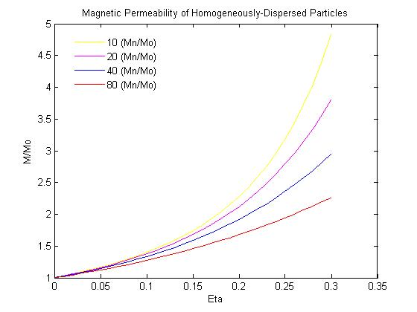

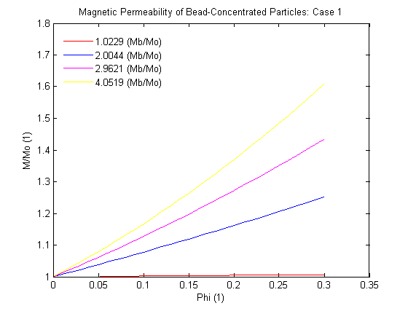

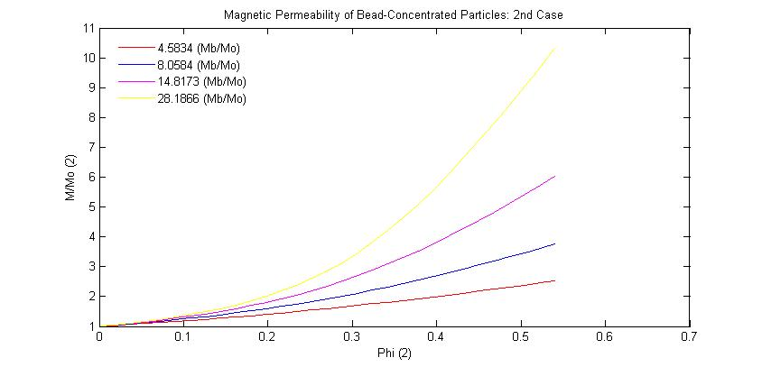

Appendix 1: Rearrangement of Bruggeman Equation: i i(i - e)/[i + (*n* - 1)e ] = 0

$η$ was switched for $δ$, $μ$ for $σ$, and assume *n* = 3, because the desired model is in three dimensions.

Thus, the new equation: \* (n - e) / (n + 2e) + (1 - )(0 -e) / (0 +2e) = 0

A common denominator, (n + 2e)(0 + 2e), was applied to both sides, which yielded:

\* [(n - e)(0 + 2e)] / [(n + 2e)(0 + 2e)] + [(1-)(0 - e) (n + 2e)] / [(n + 2e)(0 + 2e)] = 0

Both sides were multiplied by the common denominator, which simplified the expression to:

\* [(n - e)(0 + 2e)] + [(1-)(0 - e) (n + 2e)] = 0

Both sides were then multiplied by 1 / 0, giving \* [(n - e)(0 + 2e)] /0 + [(1-)(0 - e) (n + 2e)] /0 = 0

For simplicity’s sake, x was substituted for , y for e / 0, and z for n / 0. The equation was thus: x(z - y)(1 + 2y) + (1 - x)(1 - y)(z + 2y) = 0

Expanding the left gives: -xy +xz - 2xy^2 + 2xyz + z + 2y - yz - 2y^2 -xz - 2xy + xyz + 2xy^2 = 0

Factoring, we get: -2y^2 + (-x + 2xz + z - z - 2x +xz)y + z = 0

Rearranging the middle expression yields: (3x - 1)z + (2 - 3x)y, whose coefficient we set equal to the variable “m”

With the original quadratic equation, we apply the quadratic formula to get the positive root:

y = (-m + sqrt[m^2 - 4(-2)(1)]) / 2(-2)

Simplification gives us: y = ¼(m + sqrt[m^2 + 8z], given that m = (3x - 1)z + (2 - 3x)

And converted back to the original variables:

n / e = ¼(((3 - 1) \*n / 0 + (2-3)) + sqrt(((3 - 1) \*n / 0+(2 - 3))^2 + 8 \*n / 0))

The above form, with minor variation to account for bead-concentration, was used for all models, with n / e as the magnetic permeability of the colloid with respect to that of the hydrogel solvent, n / n as the fixed permeability of the nanoparticles with regard to that of the hydrogel solvent, and $η$ as the volume fraction of the nanoparticles in the aforementioned hydrogel.

Appendix 2: Equivalency of $η$ and b\*.

Given that this proof is for when beads are at 100% capacity:

b = 1 and $η$ = $Φ$

For simplicity’s sake:

x = and m= n / 0

Thus, the homogeneous equation could be written, in terms of x as such:

While the bead-concentrated equation, expanded, appears as:

.25(((3x-1)(0.25(2 m-1)+sqrt((2 m-1)^2+8 m))+(2-3x)+sqrt((((3x-1)(0.25(2 m-1)+sqrt((2 m-1)^2+8 m))+(2-3x))^2+8(0.25(2 m-1)+sqrt((2 m-1)^2+8 m))))))

Given the values of $Φ$ and b:

(0.25(2 m-1)+sqrt((2 m-1)^2+8 m)) = (2m + 1 + 2m - 1)/4 = m

Substituting m into the equation yields:

.25(((3x-1)m+(2-3x))+sqrt(((3x-1)m+(2-3x))^2+8m))

Thus, the two equations, when the beads are filled to 100% capacity, are equal.

Appendix 3: Maximum Magnetic Permeability Given Fixed Total Volume Fraction (@ 3%)

Assuming $η$ =0.03, b = (0,1], and $Φ$ = ($∞$, 0.03], then the bead-concentrated equation can be rewritten as such, in terms of $Φ$ (p):

[1/4\*(((3\*p-1)\*(1/4\*(((3\*(.03/p)-1)\*80+(2-3\*(.03/p)))+sqrt(((3\*(.03/p)-1)\*80+(2-3\*(.03/p))).^2+8\*80)))+(2-3\*p))+sqrt(((3\*p-1)\*(1/4\*(((3\*(.03/p)-1)\*80+(2-3\*(.03/p)))+sqrt(((3\*(.03/p)-1)\*80+(2-3\*(.03/p))).^2+8\*80)))+(2-3\*p)).^2+8\*(1/4\*(((3\*(.03/p)-1)\*80+(2-3\*(.03/p)))+sqrt(((3\*(.03/p)-1)\*80+(2-3\*(.03/p))).^2+8\*80)))))]

And then simplified to:

((3\*p - 1)\*(((711/(100\*p) - 78)^2 + 640)^(1/2)/4 + 711/(400\*p) - 39/2))/4 - (3\*p)/4 + (2\*((711/(100\*p) - 78)^2 + 640)^(1/2) + ((3\*p - 1)\*(((711/(100\*p) - 78)^2 + 640)^(1/2)/4 + 711/(400\*p) - 39/2) - 3\*p + 2)^2 + 711/(50\*p) - 156)^(1/2)/4 + ½

The first derivative of the above, then:

(3\*((711/(100\*p) - 78)^2 + 640)^(1/2))/16 - ((3\*p - 1)\*(711/(400\*p^2) + (711\*(711/(100\*p) - 78))/(400\*p^2\*((711/(100\*p) - 78)^2 + 640)^(1/2))))/4 + 2133/(1600\*p) - (711/(50\*p^2) + 2\*((3\*p - 1)\*(((711/(100\*p) - 78)^2 + 640)^(1/2)/4 + 711/(400\*p) - 39/2) - 3\*p + 2)\*((3\*p - 1)\*(711/(400\*p^2) + (711\*(711/(100\*p) - 78))/(400\*p^2\*((711/(100\*p) - 78)^2 + 640)^(1/2))) - (3\*((711/(100\*p) - 78)^2 + 640)^(1/2))/4 - 2133/(400\*p) + 123/2) + (711\*(711/(100\*p) - 78))/(50\*p^2\*((711/(100\*p) - 78)^2 + 640)^(1/2)))/(8\*(2\*((711/(100\*p) - 78)^2 + 640)^(1/2) + ((3\*p - 1)\*(((711/(100\*p) - 78)^2 + 640)^(1/2)/4 + 711/(400\*p) - 39/2) - 3\*p + 2)^2 + 711/(50\*p) - 156)^(1/2)) - 123/8

The derivative, set equal to 0 and solved for $Φ$ (p) yielded:

p= 0.07942619400852485805554284612265

Dividing 0.03 by p gives b:

0.03/p = 0.37770914714

The maximum permeability, / 0 was found by plugging p into the original equation: 1.2075

Thus, the maximum permeability of the ferrogel given that the volume fraction of beads in solution at 0.03, is 1.2075 , @ 0.079 beads-in-solution and 0.378 nanoparticles-in-beads.

when .3

[1/4\*(((3\*p-1)\*(1/4\*(((3\*(.3/p)-1)\*80+(2-3\*(.3/p)))+sqrt(((3\*(.3/p)-1)\*80+(2-3\*(.3/p))).^2+8\*80)))+(2-3\*p))+sqrt(((3\*p-1)\*(1/4\*(((3\*(.3/p)-1)\*80+(2-3\*(.3/p)))+sqrt(((3\*(.3/p)-1)\*80+(2-3\*(.3/p))).^2+8\*80)))+(2-3\*p)).^2+8\*(1/4\*(((3\*(.3/p)-1)\*80+(2-3\*(.3/p)))+sqrt(((3\*(.3/p)-1)\*80+(2-3\*(.3/p))).^2+8\*80)))))]

simplified

((3\*p - 1)\*(((711/(10\*p) - 78)^2 + 640)^(1/2)/4 + 711/(40\*p) - 39/2))/4 - (3\*p)/4 + (2\*((711/(10\*p) - 78)^2 + 640)^(1/2) + ((3\*p - 1)\*(((711/(10\*p) - 78)^2 + 640)^(1/2)/4 + 711/(40\*p) - 39/2) - 3\*p + 2)^2 + 711/(5\*p) - 156)^(1/2)/4 + ½

f prime

(3\*((711/(10\*p) - 78)^2 + 640)^(1/2))/16 - ((3\*p - 1)\*(711/(40\*p^2) + (711\*(711/(10\*p) - 78))/(40\*p^2\*((711/(10\*p) - 78)^2 + 640)^(1/2))))/4 + 2133/(160\*p) - (711/(5\*p^2) + 2\*((3\*p - 1)\*(((711/(10\*p) - 78)^2 + 640)^(1/2)/4 + 711/(40\*p) - 39/2) - 3\*p + 2)\*((3\*p - 1)\*(711/(40\*p^2) + (711\*(711/(10\*p) - 78))/(40\*p^2\*((711/(10\*p) - 78)^2 + 640)^(1/2))) - (3\*((711/(10\*p) - 78)^2 + 640)^(1/2))/4 - 2133/(40\*p) + 123/2) + (711\*(711/(10\*p) - 78))/(5\*p^2\*((711/(10\*p) - 78)^2 + 640)^(1/2)))/(8\*(2\*((711/(10\*p) - 78)^2 + 640)^(1/2) + ((3\*p - 1)\*(((711/(10\*p) - 78)^2 + 640)^(1/2)/4 + 711/(40\*p) - 39/2) - 3\*p + 2)^2 + 711/(5\*p) - 156)^(1/2)) - 123/8

p=0.53589281268833921932973701477307

etab=0.55981344197